Vulnerable group living in environmental hazards

Heeju Choi
Department of Geography, Simon Fraser University
GEOG 255: Geographical Information Science I
Dr. Shivanand Balram
June 23, 2021

Discussion: meaning of the errors, reliability and limitations = 2.0 marks

Abstract

This report is to determine the relationship between people, reside near routes for the hazard, and their socio-economic status. In this spatial analysis, data is collected across North Vancouver, BC. The definition of socio-economic status is defined relatively in the dataset. The relationship is observed by proximity analyses – such as join, buffer, and intersect – with graphical visualizations; young age people with low income are more likely exposed to the environmental hazard by residing near the routes of hazard. This analysis emphasizes the importance of understanding the environmental vulnerability of social minorities, and this knowledge is important for targeting a reduction in social inequalities.

Introduction

Concerns about environmental hazards have been arising over the world; they are also of compelling interest to the public because researchers often recognize a relationship between environmental hazards and socio-economic status (SES). Since the environmental hazard directly impacts human well-being, it is important to assess the current situation, investigate the cause, and suggest the best way to deal with the issue; otherwise, it may aggravate inequality in society. For instance, the EU, which recognizes the distribution of these environmental threats in the different levels of income, unemployment, and education levels across Europe, has conducted several policies to lead to significant improvements in living conditions both economically and in terms of environmental quality.¹ In this context, the objective of this report is to understand who the people are affected more severely by residing near dangerous good routing. With the advent of geographic information systems, we could address these concerns more comprehensively and objectively with the use of various proximity analyses.
Data and Methods

Three of the five given data, collected across North Vancouver, are used for analysis; route_dangerous_goods are lines indicating routes where risky material is transported; residential_land_blocks_2014 is a polygon; residential_demographic.xlsx involves demographic information – age and income- of people from residential_land_blcoks_2014. As described in figure1, the demographic data is joined into residental_land_block_2014 by their common variable, LUID. A buffer of 300m around route_dangerous_goods is created because the area most affected is roughly the band within 300m of the routes.² The intersection of the joined layer and the buffer indicates the affected residence by the dangerous good routing. The residential demograhic.xlsx initially does not have an appropriate format to be loaded into ArcGIS. The problem is resolved by changing the XLSX file into a CSV file.
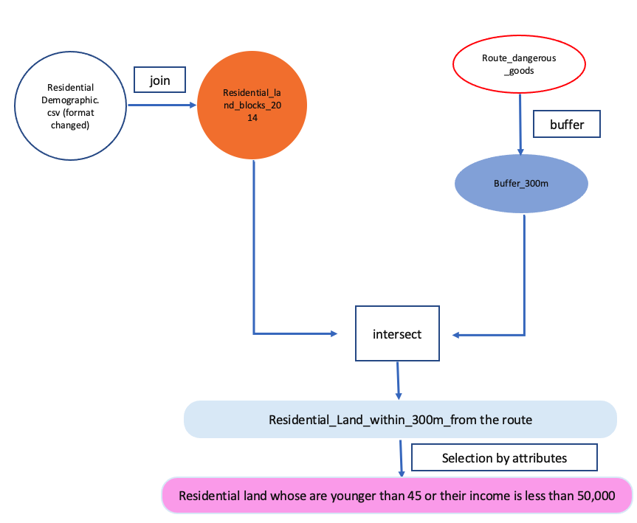
Figure 1.Workflow

Results and Discussion

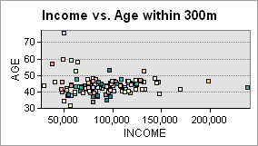
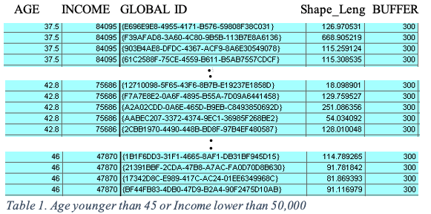
The spatial analysis using GIS helps to observe a significant relationship between environmental hazards and socio-economic status. As plotted in figure2, it has a strong positive correlation between income and age of those who live within 300m from the hazard routing; specifically, the residents within the 300m band are highly crowded in their 40s, and their income of 50,000~100,000. The age of 40s is normally considered as middle age; however, the youngest observation in this data is starting from 30s – therefore, 40s can be considered as relatively young age in this data. Furthermore, the Low-Income Cuts-offs are determined individually according to family sizes and community sizes to capture differences in the cost of living³; however, since we do not any information about such classifications, low income is unofficially determined by relatively low income to the others. By the relative definitions, table1 is selected attribute table of age younger than 45 or income lower than 50,000; more than 2/3 of the Residential_Land_within_300m_from_the_route belongs to younger than 45 or less than the income of 50,000; also, it is visualized in the map as the pink-coloured layer. In other words, the residents within 300m from the route for dangerous goods are mostly younger than 45 or earning less than 50,000. The limitation of these analysis is that young age and low income are not formally defined.
Figure 2. Relationship between Income and Age within 300m from the dangerous route

Conclusion
This spatial analysis has confirmed that lower-income and younger residents have a higher vulnerability to dangerous goods routing in North Vancouver. The study emphasizes the importance of understanding the vulnerability of social minorities, as this knowledge is essential for targeting an improvement of living conditions both economically and environmentally.

Reference

¹More action needed to protect Europe’s most vulnerable citizens from air pollution, noise and extreme temperatures. (2019). European Environment Agency. https://www.eea.europa.eu/highlights/protect-vulnerable-citizens

²Traffic-Related Air Pollution: A Critical Review of the Literature on Emissions, Exposure, and Health Effects. (2010, January). https://www.healtheffects.org/publication/traffic-related-air-pollution-critical-review-literature-emissions-exposure-and-health

³ Towards a Poverty Reduction Strategy – A backgrounder on poverty in Canada. (2021, May 26). Statistics Canada. https://www.canada.ca/en/employment-social-development/programs/poverty-reduction/backgrounder.html

